py4DSTEM and Real Space Images

**Summary:** A plausible interpretation of the real space images in py4DSTEM is proposed. The results suggest that some systematic beam intensity problem is present in the 6.7 degree twist angle data, but not in the 1.2 degree twist angle data.

**Follow-up questions:** Do we expect the intensity of the Bragg disks to vary across the moiré cell, in addition to the locations of the Bragg disks?

From the things Colin said in our meeting, I’m pretty sure that the real space images being generated from py4DSTEM are integrated dark field images. The intensity plotted on the right window is the pixel value for each diffraction pattern integrated over the region of reciprocal space defined by the green box in the left window. This is why the label reads “integrate” under “detector mode” and why the shape refers to the “virtual detector”. It is as though you had placed an aperture over the region defined by the box in the left image, and integrated all of the electrons coming through to make a dark field image on the instrument itself. You can verify that this is a reasonable interpretation also by looking at the scale bar on the right window, which is consistent with an integration taking place.

The checkerboard pattern from the 6.7 degree twist angle does seem to indicate some sort of anomaly in the data collection, because it seems as though the intensity of the beam was fluctuating periodically with sharp cutoffs as you scanned over real space.

Fortunately this issue does not appear to have occurred for the 1.2 degree twist angle, as seen in Figures 6-7. Indeed, for those pictures, it looks like there is a periodic modulation in the intensity on a diagonal. A question I have is whether we expect the actual intensity of the Bragg disks to change across the moire unit cell.

See py4DSTEM screenshots below.

Throughout, the “6.7 degree sample” was drawn from dataset 3__70x70_ss4nm_0p05s_spot9_alpha=0p55_bin=4_CL=130_80kV_C2=40um.dm4, while the “1.2 degree sample” was drawn from 6__25x25_ss4nm_2s_spot4_alpha=0p14_bin=4_CL=380_80kV_C2=10um.dm3.

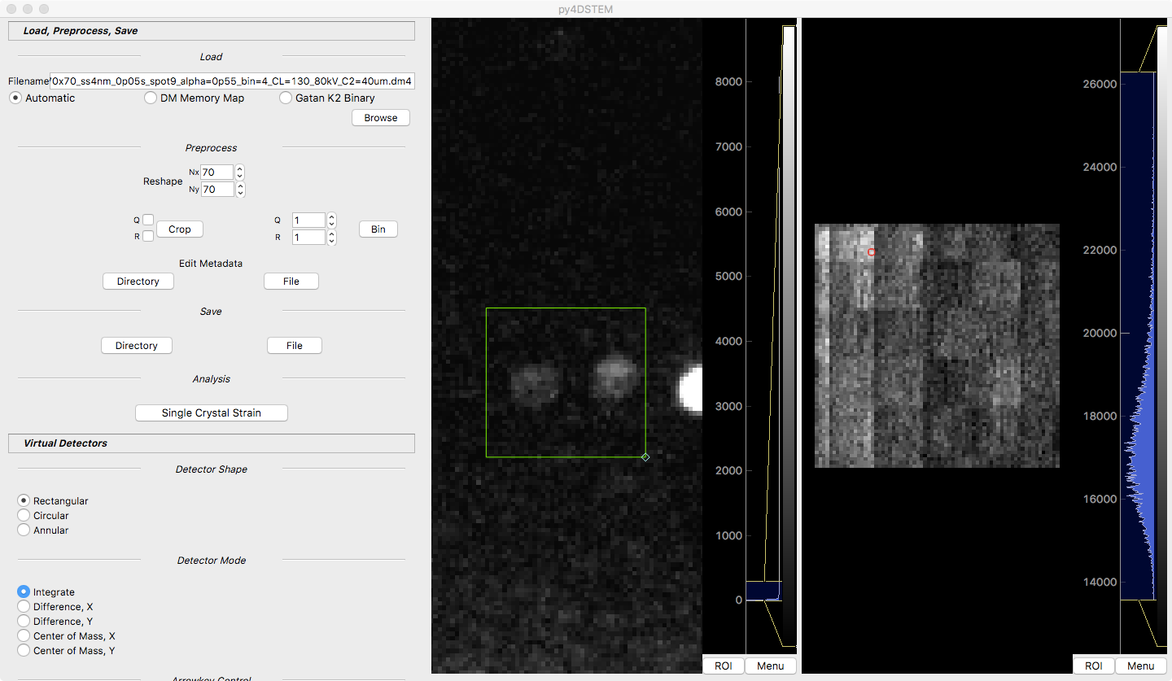

Figure 1: 6.7 degree twist angle, selecting a real space location just before the intensity step (high-intensity region).

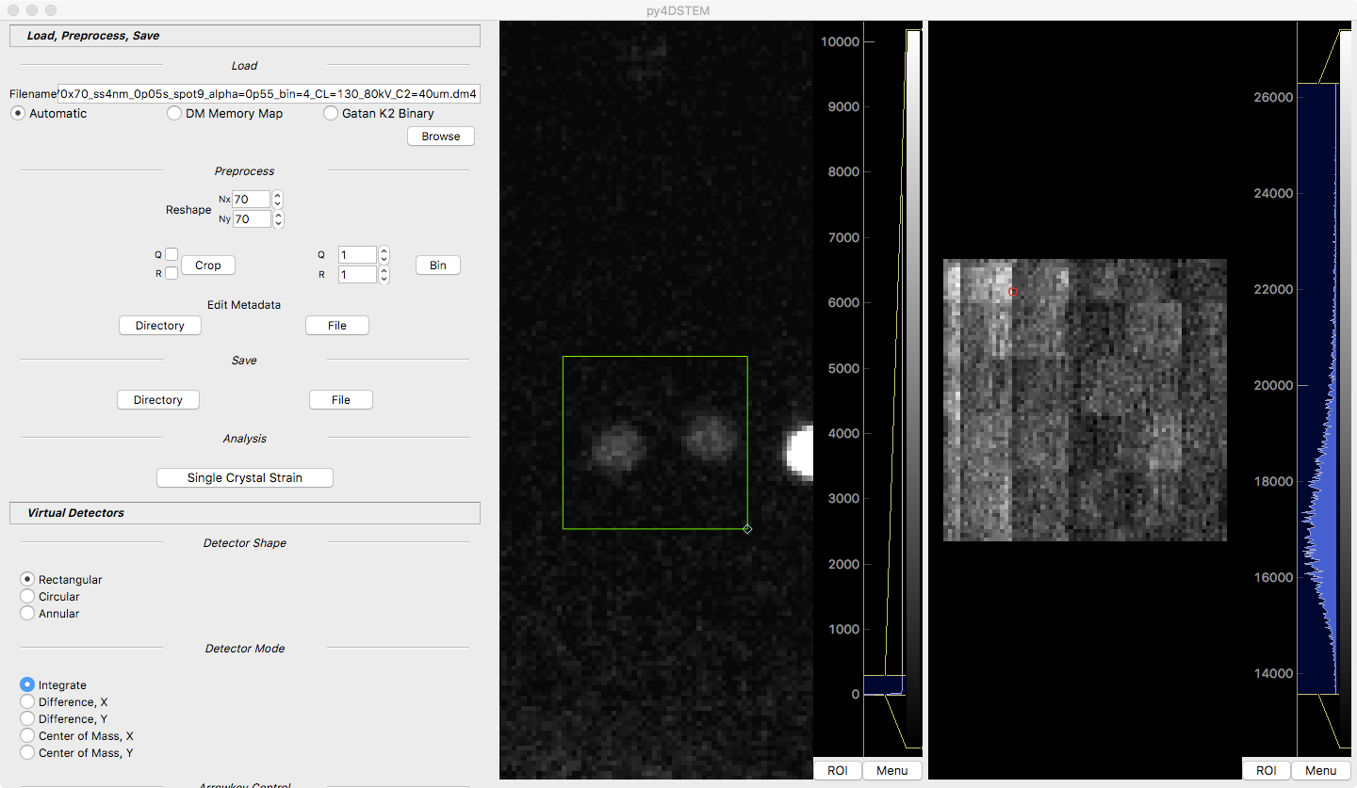

Figure 2: 6.7 degree twist angle, selecting a real space location just after the intensity step (low-intensity region).

Note how the red box has shifted in the window on the right; that is the only thing that I changed. You can see, I think, that the intensity of the elastically scattered beam in the window has gone down. This effect is very prominent if you load the 6.7 degree twist angle into py4DSTEM and slowly move the red square in the right window that defines the diffraction pattern being examined. You can see how there are discontinuities of the intensity of the center of the beam as you cross boundaries in the checkerboard pattern.

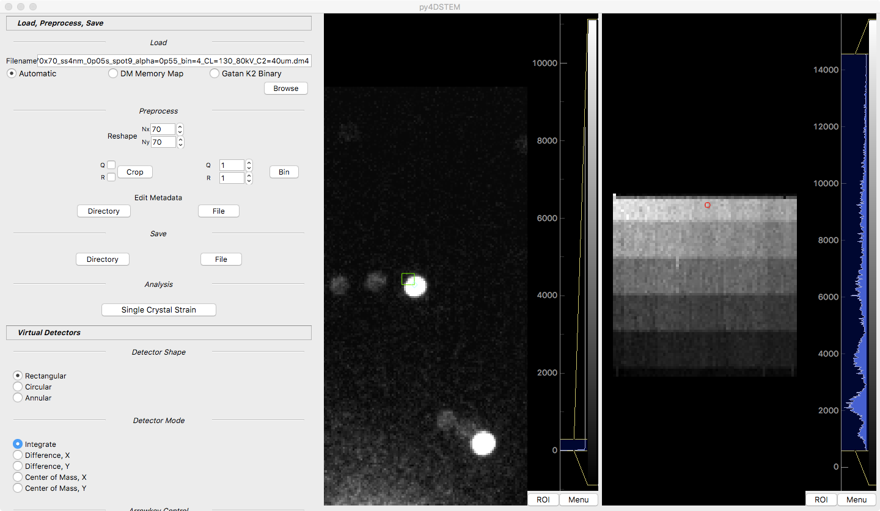

Figure 3: Looking at an hBN peak for the 6.7 degree twist angle: a lot of the hBN present in the integration region.

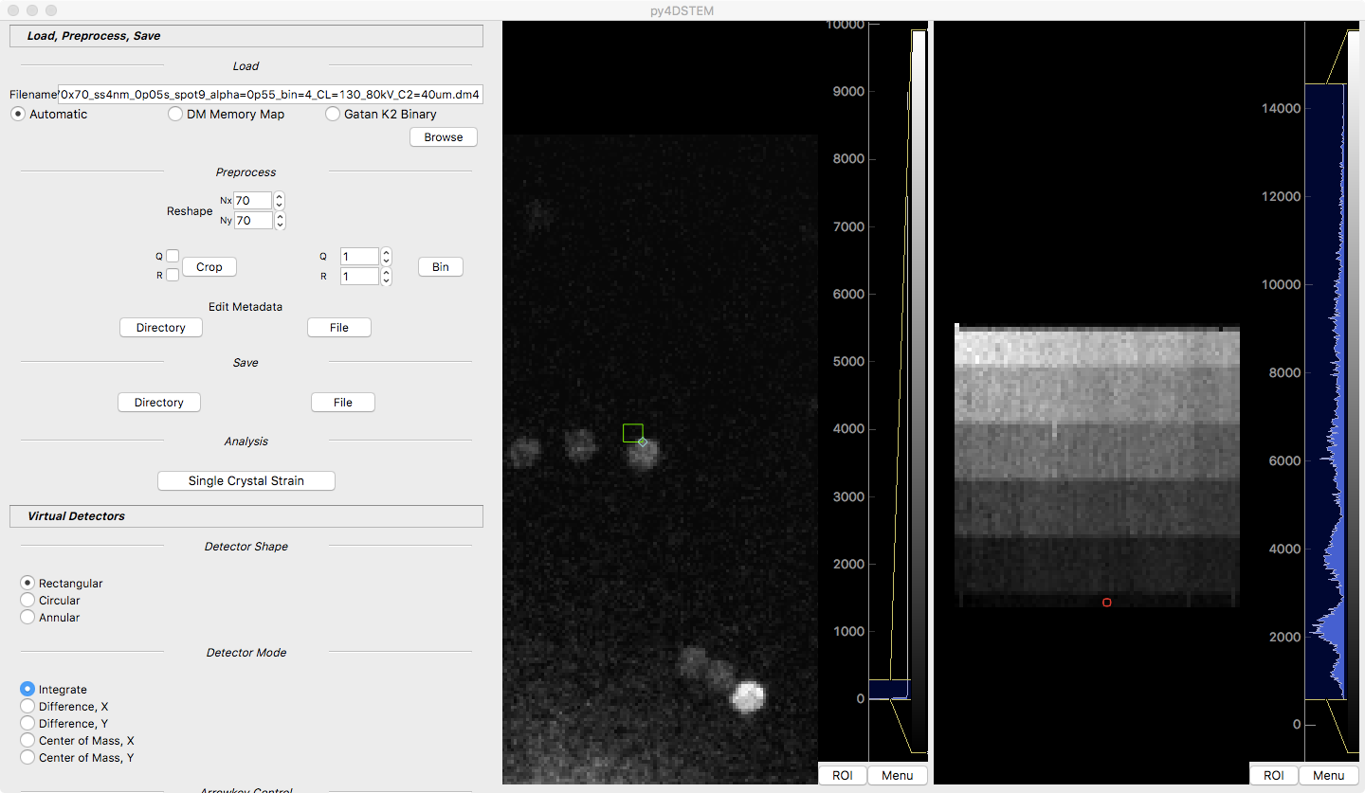

Figure 4: Looking at an hBN peak for the 6.7 degree twist angle: almost none of the hBN present in the integration region.

The only thing different between Figure 3 and 4 is which diffraction pattern I chose in the right window. The shift of the beam results in the hBN peak moving out of the integrating virtual detector region, which is why the real space intensity goes down.

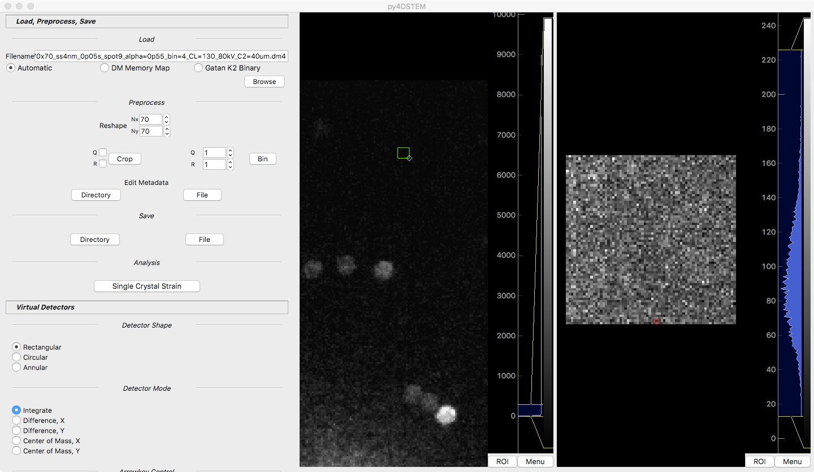

Figure 5: 6.7 degree sample, integration region set to something random far away from the beam center. When there is no appreciable elastic scattering contribution, there is no checkerboard pattern, because the beam intensity has no real effect when everything is just noise.

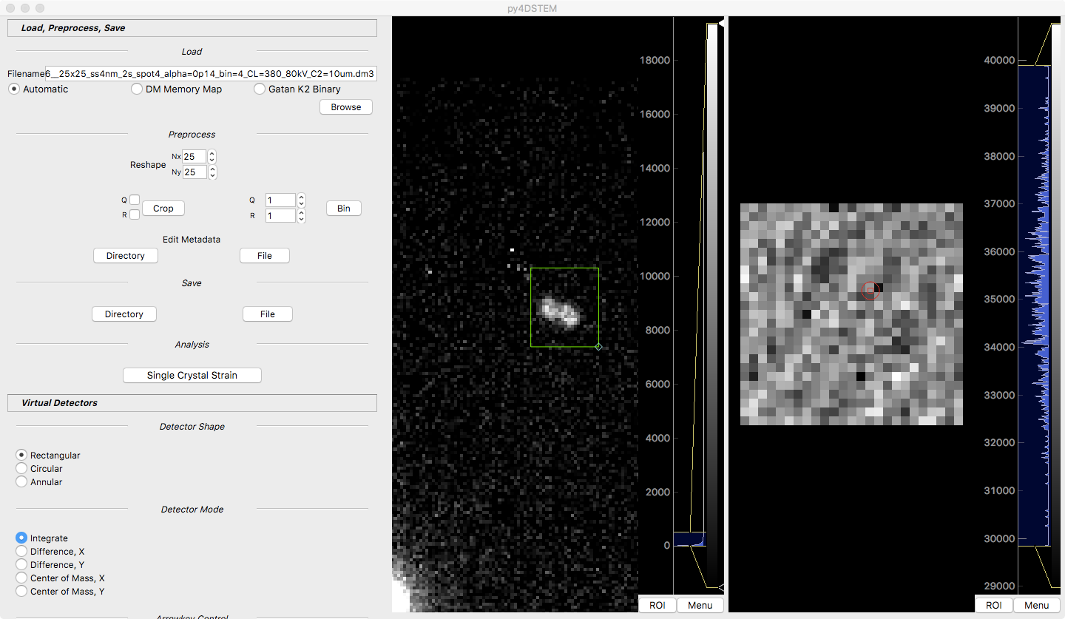

Figure 6: 1.2 degree twist angle, the weaker of the two usable graphene peaks.

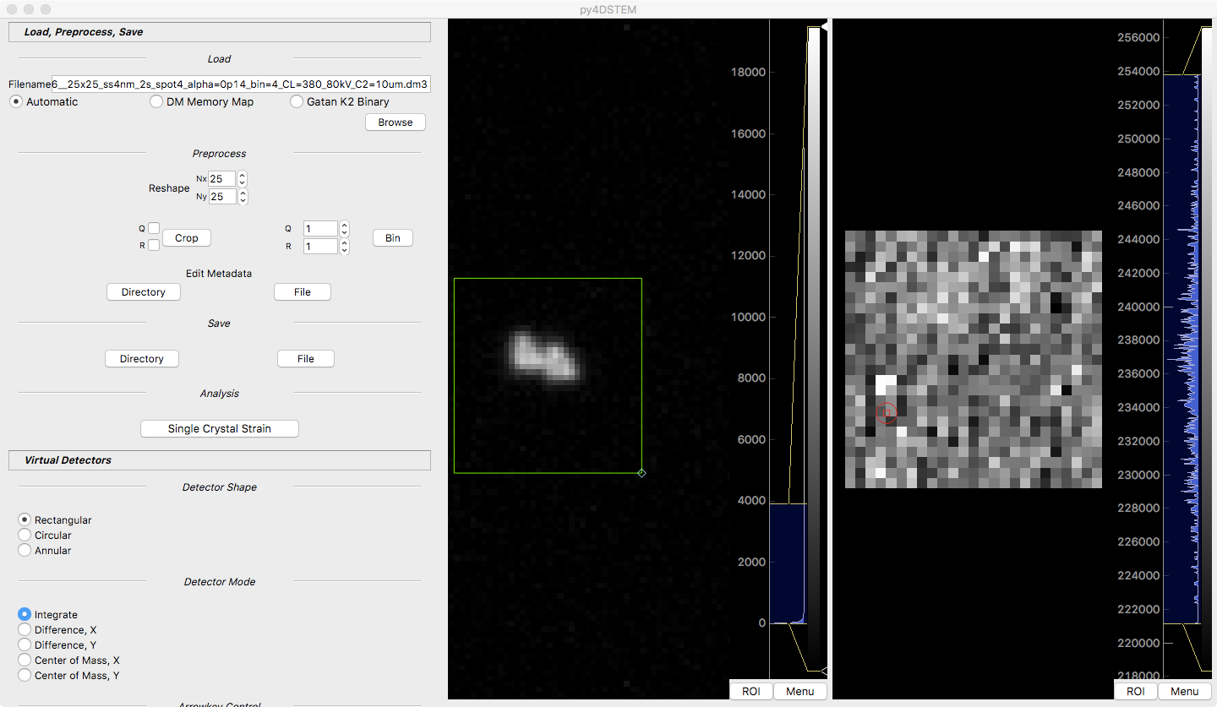

Figure 7: 1.2 degree twist angle, the stronger of the usable graphene peaks.

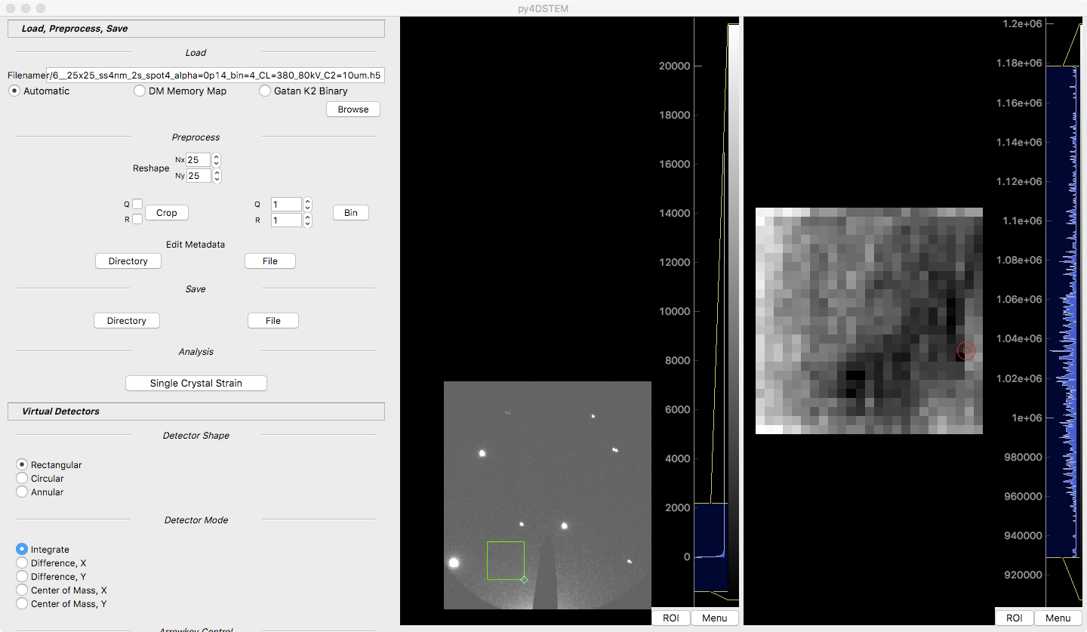

Figure 8: 1.2 degree twist angle, choosing a region where there are no peaks, to gauge fluctuations in the beam intensity. Note that the diagonal periodicity from Figures 6-7 are not present, so unlike the 6.7 degree twist angle sample, I think that the periodic variations in integrated intensity for the peaks are due to some factor other than fluctuating beam intensity. It could be because the edge of the diffraction disks is moving across a pixel boundary, or due to an actual effect of sample rotation or of varying intensity across the moire unit cell.